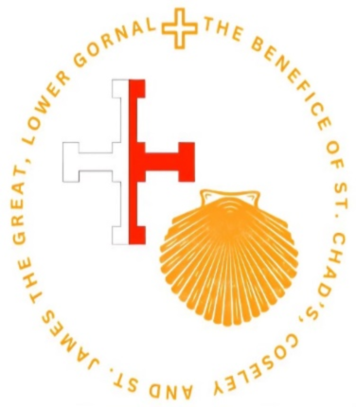
For Our Prayers Sick & Housebound: Janet Aston, Pamela Anderson, Owen Allaway Janet Bromley, Kerry Bullows, Mick Bullows Colin & Diane Bradshaw, Jackie Broom, Cheryl Ball, Jackie Bell, Chris Cleford, Carla & Craig Bolton, Emily Cousland, Michael & Carol Connochie, Michael Crowe, Christopher & Karen Carter Brian Evans, Ann Foster Jill Watts, Val Dallaway, David Dixon, Pam Edwards, Simon Glenn, Wilf Griffiths, Lorraine Garland, Gordon Gaskill, Martin Horton, Alan Halford, Margaret Holloway, Glenis Kirton, Ray Stevens, Sean Hughes, George & Marian Harris, Ron Jeavons, Jacob Smith, Adrian Shaw, Steve Rolls, Maisie & Steve Marsh, Brandon Mushi, Karen & Neale Love, Ann Lovesy, Fr. Barry Smart, Chris Smith, Josie Pountney, Stefan Cidealau, Cynthia Stokes, Rachel Thomas, Catherine Thomas, Dorothy & Alan Parsons, Eileen & John Wooldridge & Fr James Walton
THIS WEEK
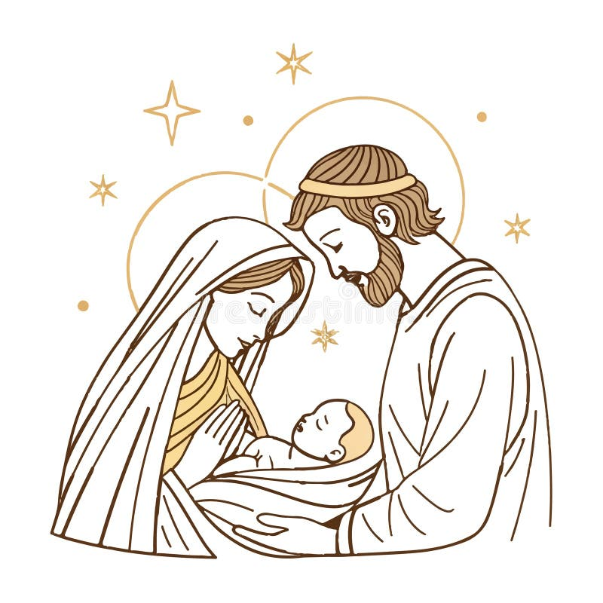
Feast of the Holy Family 8.00am Mass St. Chad 9.30am Parish Mass St James 11.00am Parish Mass St Chads 5.00pm Evening Prayer & Benediction St James Readings: Isaiah 7:10-14,, Psalm 24, Romans 1:1-7 Matthew 1:18-24
Monday 29th Octave of Christmas
Tuesday 30th Octave of Christmas
Wednesday 31st Octave of Christmas 9.30am Mass St Chad
Thursday 1st New Year’s Day 12.00pm Feast of the Holy Mother of God
Friday 2nd St Basil No Mass St. Chad
Saturday 3rd The Holy name of Jesus 10.00am Mass with the Rosary St. Chad 7.00pm St Chad’s Christmas Party
January 4th Feast of the Epiphany of the Lord 8.00am Mass St. Chad 9.30am Mass St James 11.00am Mass St. Chad Readings: Isaiah 7:10-14,, Psalm 24, Romans 1:1-7 Matthew 1:18-24

The Parish Church of St. Chad Coseley Fr. Gary Hartill father,gary@outlook.com 01902 881357 www.stchadstjames.co.uk

Birthdays 27th Cath Tope
Recently Departed Gail Jones, Roger Stevens, Denzil Smith, Hilda Busby & Vera Prince
Years Mind 28th Martha Hartshorne, Cynthia Hobbs 29th Doreen Smith, Peter Carter, 30th Sue Cooper, Arthur Ponting, 31st Thomas Waterhouse, 1st Florence Hubble, Gordon Jones, Lily Powell, Henrietta Briscoe, Charles Rumbold, Joan Turner, 2nd Ada Hughes, Iris Hyde, Gwen Langford, Lily Johnson, 3rd Alice Parker, Louise Hughes, Michael Ward, Jean Clarke
Forthcoming Events
1st Jan New Year’s Day 12noon St James 3rd Jan Christmas Party St Chad’s All are welcome Bring & Share 7.00pm 31st Jan St Chad’s Burns Night £12.50 See Kerry for Tickets
Reminder Over the Christmas period, all Sunday Services as NORMAL Why don’t you come along and see the changing scenes of the Crib
From the 1st of January we will be starting a new prayer list for the Sick and the Housebound. If you want to add a family member or a friend, for us to pray for please let either Fr Gary, John Wardell or churchwardens Kerry & Diane know.
Hope you’ve all had a wonderful Christmas, many thanks to everyone for all cards & gifts for myself and Carole. Wishing you all a blessed 2026

Sunday 28 December Feast of The Holy Family
Entrance Antiphon The shepherds went in haste, and found Mary and Joseph and the infant lying in a manger.
Collect O God, who were pleased to give us the shining example of the Holy Family, graciously grant that we may imitate them in practising the virtues of family life and in the bonds of charity, and so, in the joy of your house, delight one day in eternal rewards. Through our Lord Jesus Christ, your Son, who lives and reigns with you in the unity of the Holy Spirit, God, for ever and ever.
First reading A reading from the book of Sirach
The Lord honoured the father above the children, and he confirmed the judgement of the mother over her sons. Whoever honours his father atones for sins, and whoever glorifies his mother is like one who lays up treasure. Whoever honours his father will be gladdened by his own children, and when he prays he will be heard. Whoever glorifies his father will have long life, and whoever obeys the Lord will refresh his mother. O son, help your father in his old age and do not grieve him as long as he lives; even if he is lacking in understanding, show indulgence; in all your strength do not despise him. For kindness to a father will not be forgotten, and against your sins it will be credited to you. The word of the Lord. Thanks be to God
Responsorial Psalm Blessed are all who fear the LORD, and walk in his ways.
Blessed are all who fear the LORD, and walk in his ways! By the labour of your hands you shall eat. You will be blessed and prosper. R
Your wife like a fruitful vine in the heart of your house; your children like shoots of the olive around your table. R
Indeed thus shall be blessed the husband who fears the LORD. May the LORD bless you from Sion May you see Jerusalem prosper all the days of your life! R
Second reading A reading from the letter of St Paul to the Colossians
Brothers and sisters: Put on, as God’s chosen ones, holy and beloved, compassionate hearts, kindness, humility, meekness, and patience, bearing with one another and, if one has a complaint against another, forgiving each other; as the Lord has forgiven you, so you also must forgive. And above all these put on love, which binds everything together in perfect harmony. And let the peace of Christ rule in your hearts, to which indeed you were called in one body. And be thankful. Let the word of Christ dwell in you richly, teaching and admonishing one another in all wisdom, singing psalms and hymns and spiritual songs, with thankfulness in your hearts to God. And whatever you do, in word or deed, do everything in the name of the Lord Jesus, giving thanks to God the Father through him. The word of the Lord. Thanks be to God
Gospel Acclamation Alleluia, alleluia! May the peace of Christ reign in your hearts; let the message of Christ find a home with you. Alleluia!
Gospel A reading from the Holy Gospel according to Matthew
When the Magi had departed, behold, an angel of the Lord appeared to Joseph in a dream and said, ‘Rise, take the child and his mother, and flee to Egypt, and remain there until I tell you, for Herod is about to search for the child, to destroy him.’ And he rose and took the child and his mother by night and departed to Egypt and remained there until the death of Herod. This was to fulfil what the Lord had spoken by the prophet: ‘Out of Egypt I called my son. But when Herod died, behold, an angel of the Lord appeared in a dream to Joseph in Egypt, saying, ‘Rise, take the child and his mother and go to the land of Israel, for those who sought the child’s life are dead.’ And he rose and took the child and his mother and went to the land of Israel. But when he heard that Archelaus was reigning over Judea in place of his father Herod, he was afraid to go there, and being warned in a dream he withdrew to the district of Galilee. And he went and lived in a city called Nazareth, so that what was spoken by the prophets might be fulfilled, that he would be called a Nazarene. The Gospel of the Lord. Praise to you, Lord Jesus Christ.
Prayer over the Offerings We offer you, Lord, the sacrifice of conciliation, humbly asking that, through the intercession of the Virgin Mother of God and Saint Joseph, you may establish our families firmly in your grace and your peace. Through Christ our Lord.
Communion Antiphon Our God has appeared on the earth, and lived among us.
Prayer after Communion Bring those you refresh with this heavenly Sacrament, most merciful Father, to imitate constantly the example of the Holy Family, so that, after the trials of this world, we may share their company for ever. Through Christ our Lord

